Design a database for Zen class programme

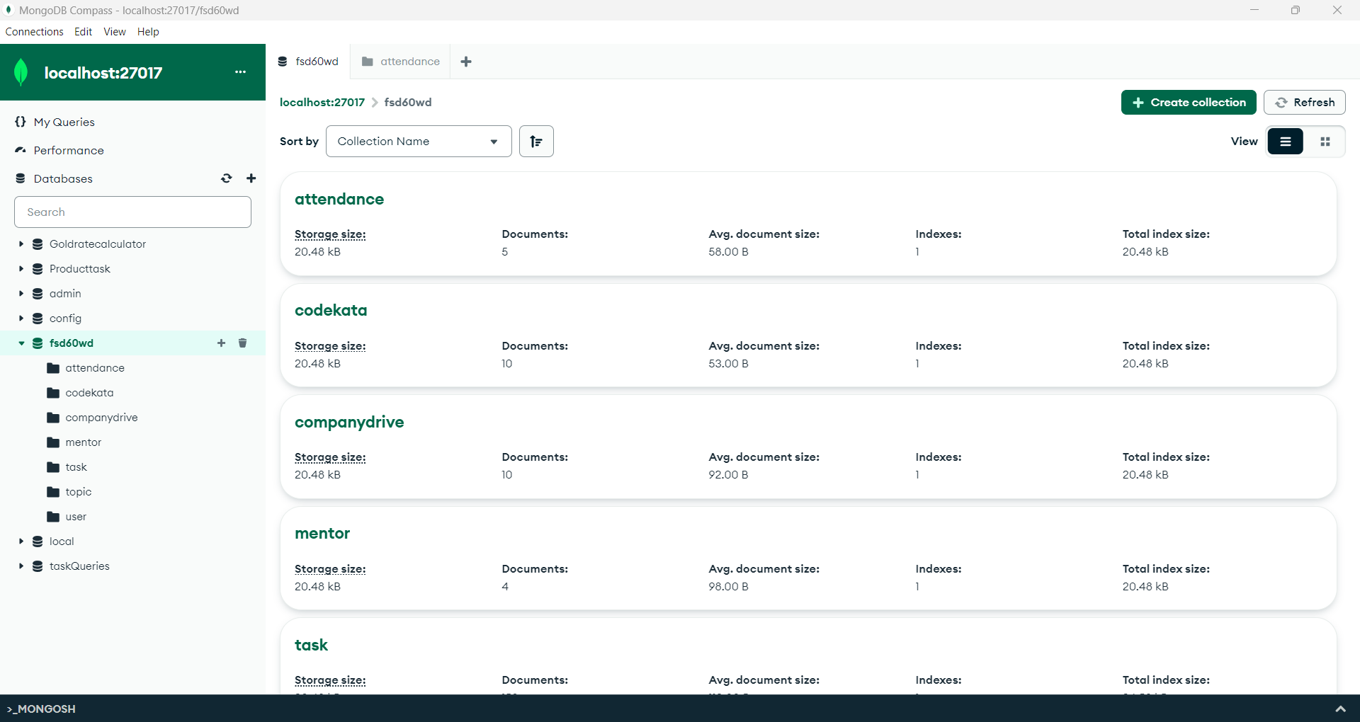

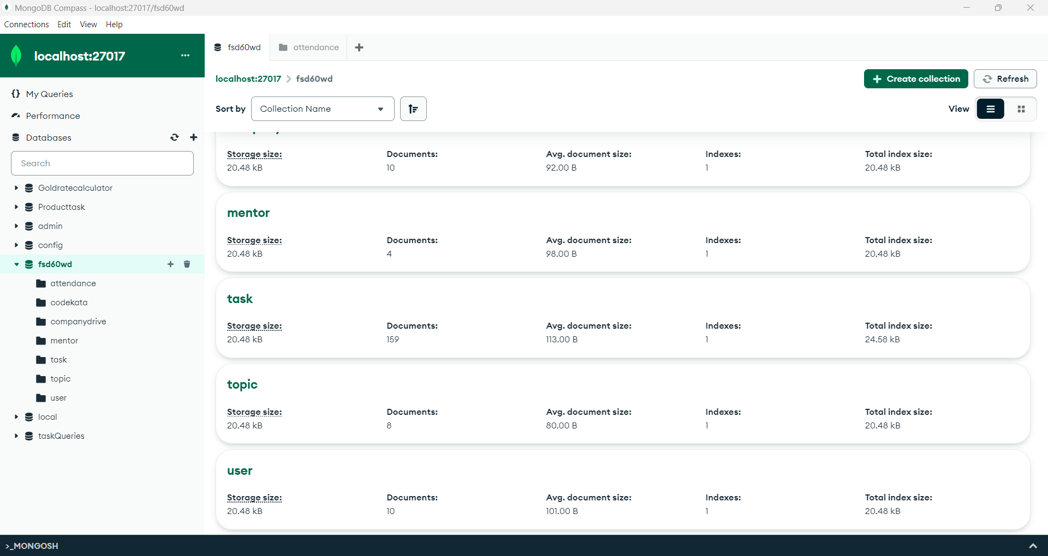

1. Find all the topics and tasks which are thought in the month of October

Db.topics.aggregate([

{

$lookup: {

from : “tasks”,

localfield: “topicid”,

foreignfield: “topicid”,

as: “taskinfo”

}

},

{

$match: {

$and: [

{ topic_date: {$gte: new Date(“2020-10-01”),$lt: new Date(“2020-11-01”)}

},

{

$or: [

{“taskinfo.due_date”: {$gte: new Date(“2020-10-01”), $lt: new Date(“2020-11-01”)}},

{“taskinfo.due_date: {$exists: false} }

]

}

]

}

},

{

$project: {

_id: 0,

topicid: 1,

topic: 1,

topic_date: 1,

tasks: “$taskinfo.task”,

due_dates: “$taskinfo.due_date”

}

}

]}

2. Find all the company drives which appeared between 15-oct-2020 and 31-oct-2020

db.companydrives.find({

$or: [

{drive_date: { $gte: new Date(“2020-oct-15”),$lte: new Date(“2020-oct-31”)}}

]

})

3. Find all the company drives and students who are appeared for the placement

db.companydrives.aggregate([

{

$lookup: {

from: “users”,

localField: “userid”,

as: “userinfo”

},

},

{

$project: {  
_id: 0,  
company: 1,  
drive_date: 1,  
“info.name”: 1,  
“info.email”: 1,  
“info.userid”: 1,  
},  
},  
])

4. Find the number of problems solved by the user in codekata?

db.codekata.aggregate([

{

$lookup: {

from: “users”,

localField: “userid”,

foreignField: “userid”,

as: “userinfo”

},

},

{

$project: {

_id: 0,

userid: 1,

solved_problems: 1,

“userinfo.name”: 1,

},

},

])

5. Find all the mentors with who has the mentee's count more than 15?

db.mentors.find({mentee_count:{$gte:15}})

6. Find the number of users who are absent and task is not submitted between 15-oct-2020 and 31-oct-2020?

db.attendence.aggregate([  
{  
$lookup: {  
from: “topics”,  
localField: “topicid”,  
foreignField: “topicid”,  
as: “topics”,  
},  
},  
{  
$lookup: {  
from: “tasks”,   
localField: “topicid”,  
foreignField: “topicid”,  
as: “tasks”,  
},  
},  
{ $match: { $and: [{ staus: false }, { “tasks.submitted”: false }] } },  
{  
$match: {  
$and: [  
{  
$or: [  
{ “topics.topicDate”: { $gte: new Date(“2020–10–15”) , $lte: new Date(“2020–10–31”) } }  
],  
},  
{  
$or: [  
{ “tasks.task_date”: { $gte: new Date(“2020–10–15”) , $lte: new Date(“2020–10–31”) } },  
],  
},  
],  
},  
},  
{  
$count:”Absentees”,  
},  
])